GHCR with Docker - DevOps Practical Report
Name: Kanishk Parashar
Project: Push Docker Image to GitHub Container Registry (GHCR)
Date: February 2026

Objective
To create a Docker image, build it, and push it to GitHub Container Registry using Docker.

Project Files
1. app.py
2. requirements.txt
3. Dockerfile

app.py
from flask import Flask
app = Flask(__name__)
@app.route("/")
def home():
return "Hello from GHCR Flask App!"
if __name__ == "__main__":
app.run(host="0.0.0.0", port=5000)

requirements.txt
flask

Dockerfile
FROM python:3.9-slim
WORKDIR /app
COPY . .
RUN pip install -r requirements.txt
EXPOSE 5000
CMD ["python", "app.py"]

Steps Performed
1. Created project directory: mkdir ght-demo
2. Created app.py, requirements.txt, and Dockerfile
3. Built Docker image using: docker build -t ghcr.io/pt-kanishk/ght-demo .
4. Logged into GHCR: docker login ghcr.io
5. Entered GitHub username and personal access token
6. Pushed image: docker push ghcr.io/pt-kanishk/ght-demo
7. Verified image on GitHub Packages

Common Errors Faced
1. Repository name must be lowercase.
2. Missing build context (.).
3. COPY requires source and destination.

Practical Screenshots
Screenshot 1
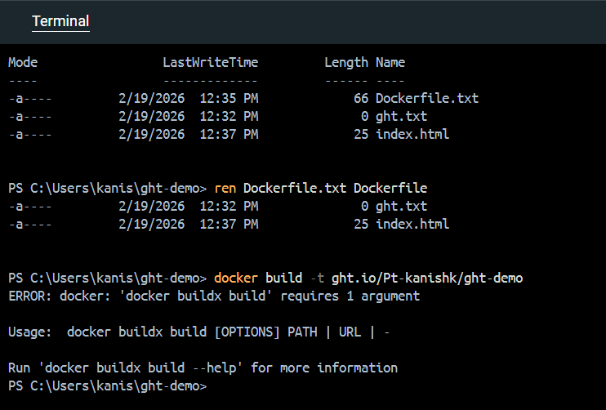
Screenshot 2
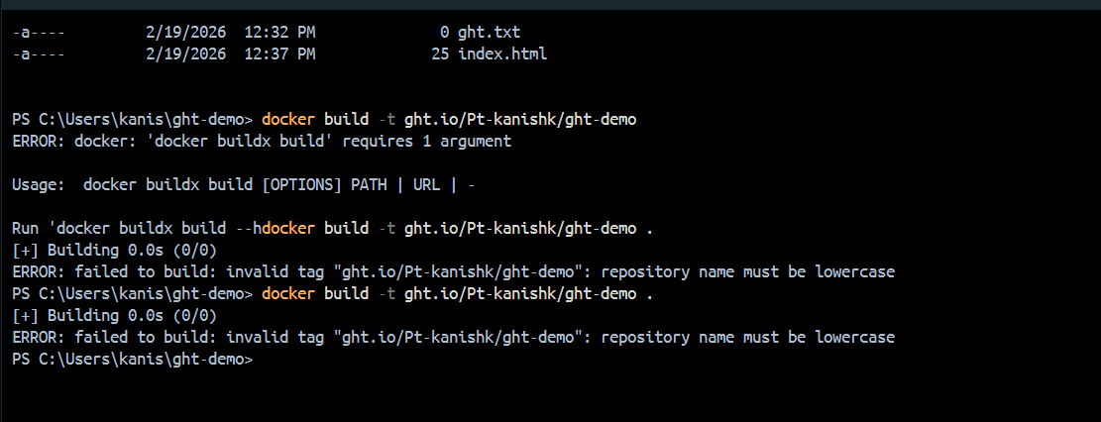
Screenshot 3
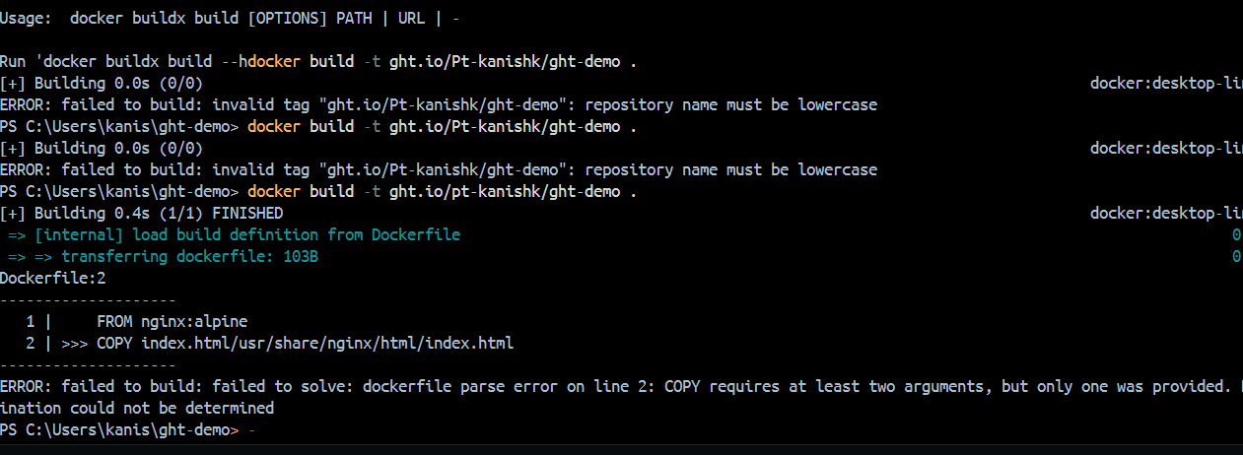
Screenshot 4
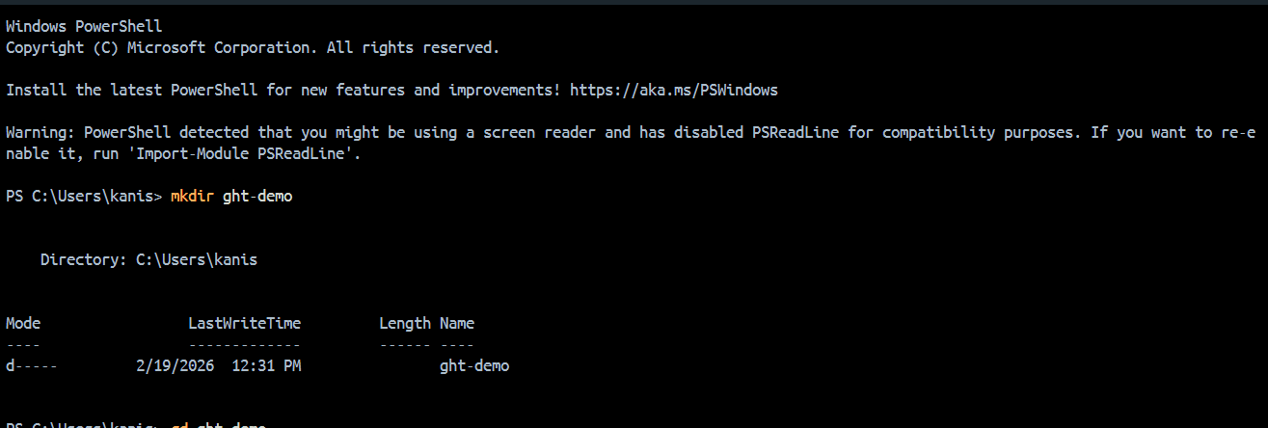
Screenshot 5
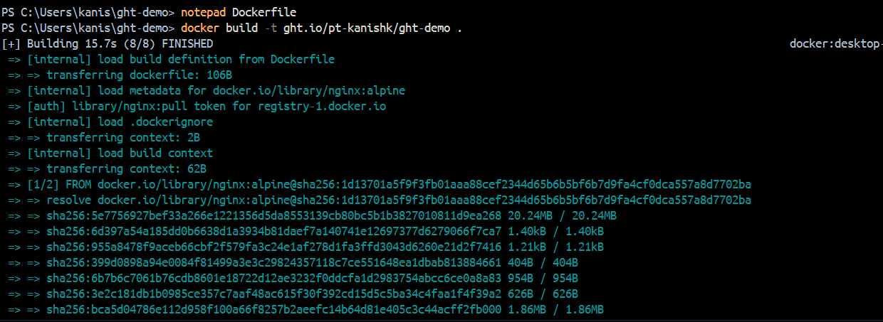
Screenshot 6
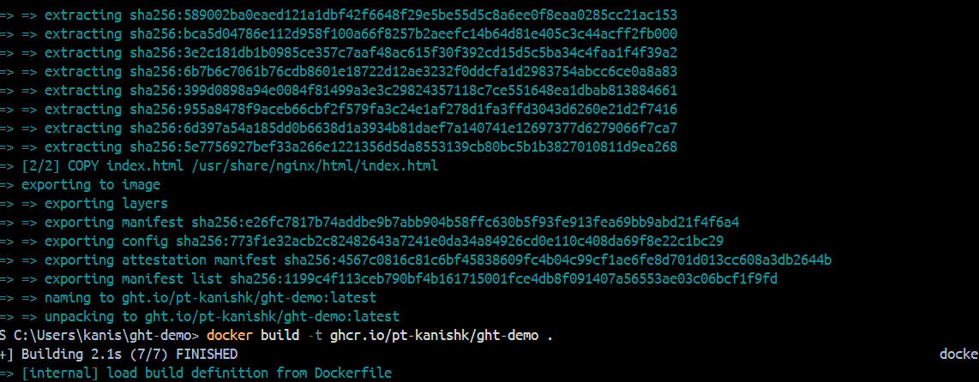
Screenshot 7
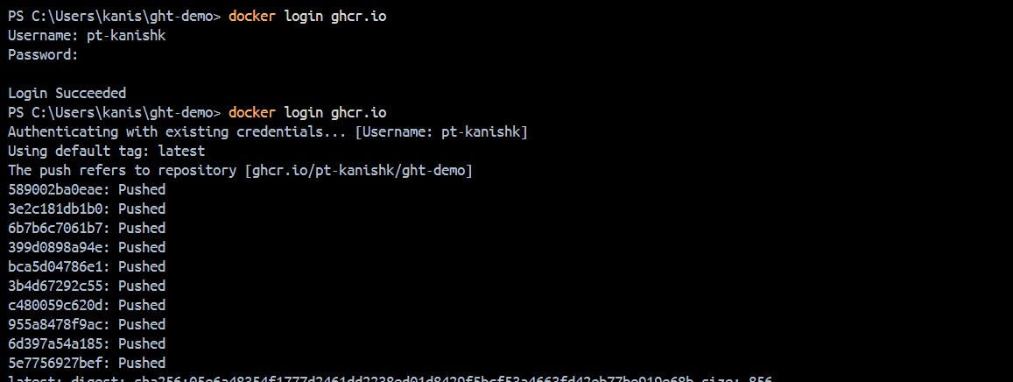
Screenshot 8
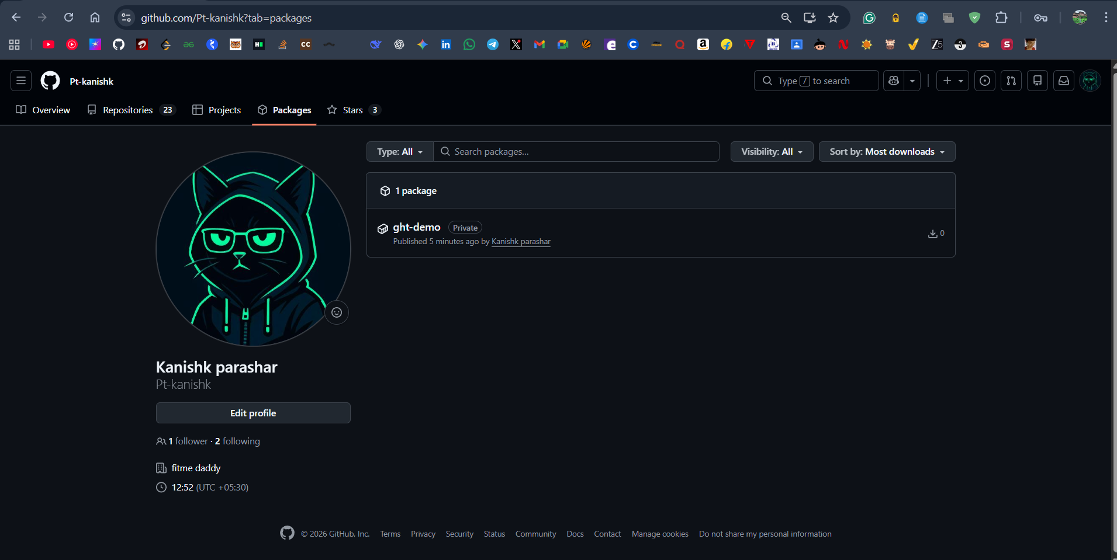
Screenshot 9
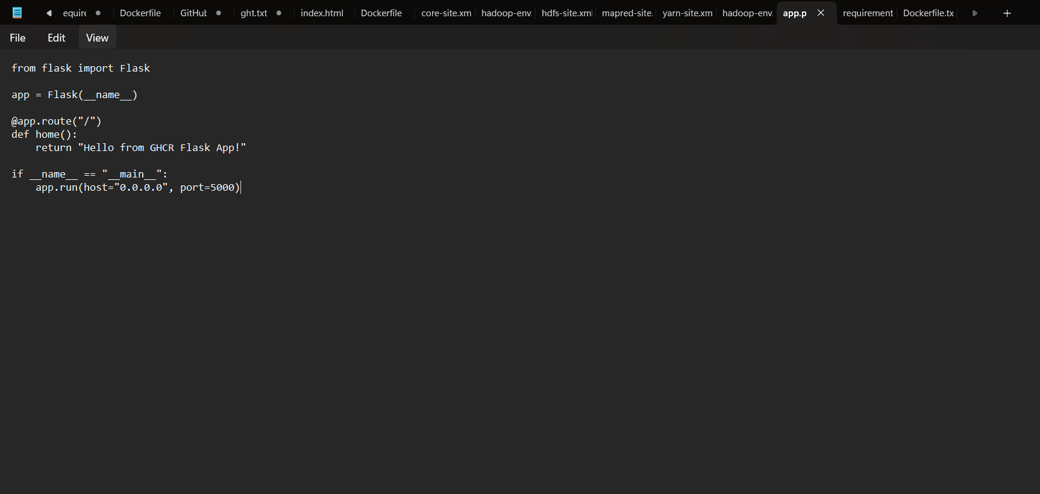

Result
Docker image was successfully pushed to GitHub Container Registry and verified.

Conclusion
This practical helped in understanding Docker build, login, and push process with GHCR.

